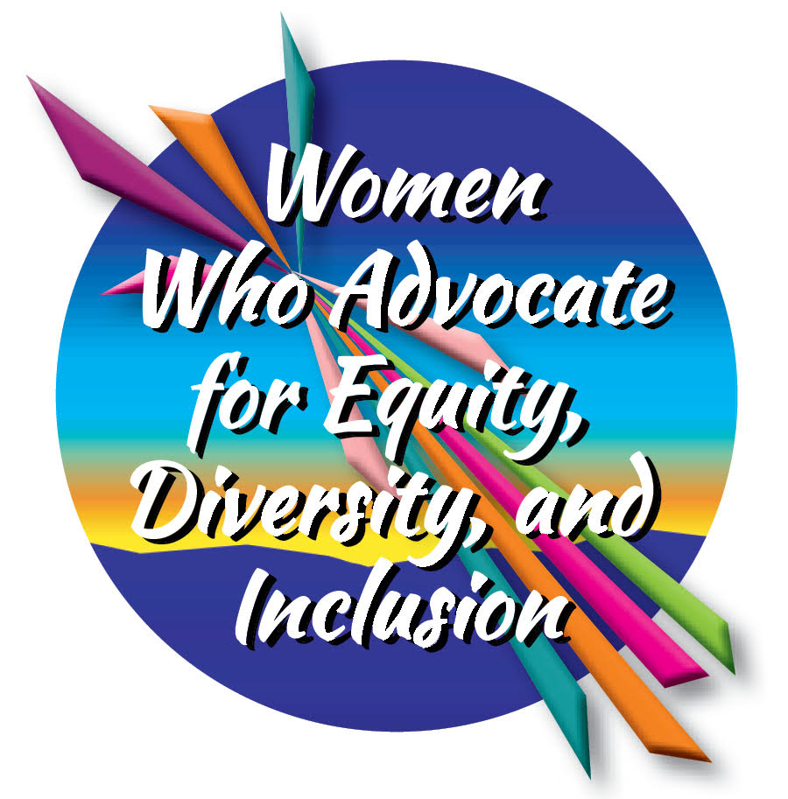
2024 Women's History
Tool Kit

National Women's History Alliance
nationalwomenshistoryalliance.org

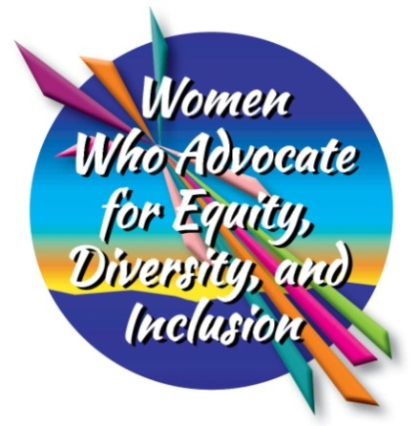

Women Who Advocate for Equity, Diversity and Inclusion
The 2024 Women’s History Tool Kit theme recognizes women throughout the country who understand that for a positive future, we need to eliminate bias and discrimination entirely from our lives and institutions.
Women from every background have long realized that an uneven playing field will never bring equality or justice. Countless people feel the critical need to speak up and work harder for fairness in our institutions and social interactions.
During 2024, we recognize the example of women who are committed to embracing everyone — and excluding no one — in our common quest for freedom and opportunity. They know that people change with the help of families, teachers and friends, and that young people in particular need to learn the value of hearing from different voices with different points of view as they grow up.
Today, equity, diversity and inclusion are powerful driving forces that are having a wide-ranging impact on our country. Advocacy is an action of courage. Often advocacy challenges and changes society's long held assumptions. Throughout 2024, we honor local women from the past and present who have taken the lead to show the importance of change and to establish firmer safeguards, practices and legislation reflecting these values. Following decades of discrimination, we are proud to celebrate women who work for basic inclusion, equality and fairness.
Who are the women in your community or organization that you will honor?
2024 Logo download https://nationalwomenshistoryalliance.org/2024-whm-theme/

A Toolkit for Enhancing Student Knowledge of Women’s History
What’s more important than equality among all people? That’s why the National Women’s History Alliance has deemed “Women Who Advocate for Equity, Diversity and Inclusion” as the theme for 2024. It recognizes women's advocacy as the source of societal changes that have expanded our possibilities and have moved history forward.
But there’s more work to do.
This past year, a tide has pushed back against equity, diversity, and inclusion. That makes this work more important than ever. It takes courage to advocate for principles when established forces aim to misinterpret, exploit, or discredit them.
This guide provides practical advice for educators, community activists, and parents to engage students aged 10-18 in exploring women's history both locally and nationally.
Sharing Women’s History in Classrooms
Women’s history is a vital component of our shared human narrative, yet it is often overlooked or marginalized in traditional educational settings. Teachers face the constant challenge of covering an incredible amount of material in multiple subjects. Teachers simply run out of time.
This may open opportunities for parent volunteers or volunteer organizations to step forward to provide additional information about women who have shaped history. The stories of the women themselves are extraordinarily valuable, and there are many ways to create interactive ways to present the new material.
There’s an important first step before moving forward. Anyone attempting to offer help needs to understand what the kids are learning. How is the textbook? Many are out-of-date but are too expensive to replace. It’s important to know what the children are reading in class.
Educators Might Consider:
- Assign students a biography project where they research and present the life of a notable woman in history. Reports can highlight the achievements, the challenges faced, and the impact of the individual on society.
- Assign research projects that allow students to delve into specific aspects of women's history. This not only builds research skills but also enables them to become experts on a particular topic.
- Encourage students to express their understanding of women's history through artistic mediums such as writing, poetry, art, and music. Host exhibitions or performances to showcase their work.
- Suggest that a group gather to put together a timeline for women’s history.
- Ensure that women's perspectives are included in lessons across different subjects, not just history. For example, discuss literature written by women, explore scientific contributions by women, and incorporate women's achievements in mathematics.
- Would the school schedule a student-led assembly? Provide opportunities for students to organize and lead assemblies or events celebrating women's history. This empowers them to take ownership of their learning and share their knowledge with peers.

Consider The Outside World:
Connect historical events with current events to emphasize the ongoing relevance of women's history. Discuss news articles or documentaries that highlight contemporary issues related to gender equality.
- Current news is important, but so is advertising. One eye-opening project is to have students choose one night (or one week) to take notes on the advertisements they see on television, online or in magazines.
Parents and/or Other Organizations Might Offer Assistance
If the teachers are open to receiving additional information from parents or an outside organization, then:
- Suggest additional reading materials that highlight the achievements of women from various backgrounds, ethnicities, and time periods.
- Suggest guest speakers and role models who might be willing to spend an hour or two with the students, talking about their work. This provides real-life examples of women breaking barriers and excelling in various fields.
- While in-person visits are wonderful, virtual visits can broaden the field of women who are invited.
Planning a Women’s History Month Outside the Classroom
Either volunteers or educators might enjoy sponsoring a Women’s History Month during March. If the event culminates in a History Evening or History Saturday, then the experience can be shared with families and the community.
Depending on the age of the students, here are ideas:
- A poster display or students studying and dressing up as a single character. If you have many students, set up “stations” around a room where parents and other audience members can visit and chat with the various people being represented.
- Older students might enjoy staging debates on women’s rights. While it’s unpleasant to think of someone arguing against women voting, it can also be instructive. Why did women not get the vote until 1920?
- Stage a play about women’s history. Students choose the time period and put together the script. Many adults participate in “re-exactor” groups. If you happen to be in a town where “re-enacting” is popular, the chances are excellent that you can call on some people for more volunteer help.
Organize a Book Club
Organize a women's history book club where students read age-appropriate books or articles about influential women. Discussions can center on the challenges these women faced and how they overcame them.

Community Partnerships and Resources
- Partner with local women's organizations and community groups to create events or workshops centered around women's history. This fosters community engagement and strengthens the connection between schools and local resources.
- Investigate your community for items that represent women’s contributions to history. Organize field trips to local museums, historical sites, and landmarks that highlight women's contributions to the community.
- Check out the public library. There may be oral histories from people living in the past with the tapes or transcripts on file at the library.
- Is there a local historical society? If so, the students might be able to visit. There may be diaries or letters by women that are on file there. Photographs would be enormously interesting to people of all ages.
- Organize a career panel with women representing diverse professions. This exposes students to a wide range of career possibilities and reinforces the message that they can succeed in any field they choose.

Involving Families and the Community
- Encourage students to interview women in their community, such as family members, teachers, neighbors, or local professionals, to learn about their experiences. Stories from these people can be surprising and enlightening.
- Remind students that there are different types of histories. What about a family history through recipes? If a student collected family recipes with notations about each dish, the collection could be a gift for so many.
- Some families have basements full of “stuff.” If parents will permit it, ask students to poke around to see what they have. Do they have old kitchen tools? An old iron? An old radio or TV? Students can photograph what they find and report back as to what they have learned.
Other Resources:
- There are great websites dedicated to women’s history. In addition to the www.nationalwomenshistoryalliance.org, look at www.monumentalwomen.org and the National Collaborative of Women’s History Sites www.ncwhs.org. Suggest students explore these for subjects that interest them.
- Consider whether there are documentaries or films that are appropriate. Host screenings followed by discussions to deepen students' understanding and critical thinking skills.
- Explore podcasts and webinars focused on women's history. Create listening or viewing guides to facilitate discussions and reflections, encouraging students to analyze and share their thoughts.

Conclusion
By actively integrating women's history into the classroom and community, parents and teachers empower students to recognize the invaluable contributions of women throughout history. This guide emphasizes the importance of a holistic approach, combining curriculum changes, guest speakers, community engagement, multimedia resources, and student empowerment to create a comprehensive and inspiring educational experience. Together, educators, parents, and students can contribute to a more inclusive and equitable future by acknowledging and celebrating the achievements of women.

